Double materiality assessment 2026
Sustainability Report 2026
Hannah Weber · 30 September 2026 · WE-HSE-RPT-0031
Approved by the Executive Board on 29 September 2026 (with one change: financial score of 'Cyber security of assets' raised from 3.4 to 4.0).

1. Approach
For the first time Weyland has carried out a double materiality assessment following the ESRS 1 logic: a topic is material if it has a significant impact on people or the environment (impact materiality) or if it creates significant financial risks or opportunities for Weyland (financial materiality). The assessment replaces the 2023 single-materiality matrix.
- Long list of 32 topics from ESRS topical standards, peer reports and our risk register
- Online survey of 312 stakeholders (employees, neighbours, suppliers, lenders, NGOs) in June 2026
- Twelve interviews, including Hanseatic Infrastructure Bank, Arcturus Steel, Marlow Ecology and two community councils
- Scoring workshop on 9 July 2026 with heads of department; scale 1 (low) to 5 (very high)
- Threshold 3.0 on either axis

2. Results
Fourteen of the fifteen short-listed topics are material. Climate change mitigation, health and safety and marine biodiversity lead on impact; climate change, grid integration and community acceptance lead on financial materiality. Only water use is not material for a wind and solar business; diversity and inclusion and circularity only just pass the threshold.
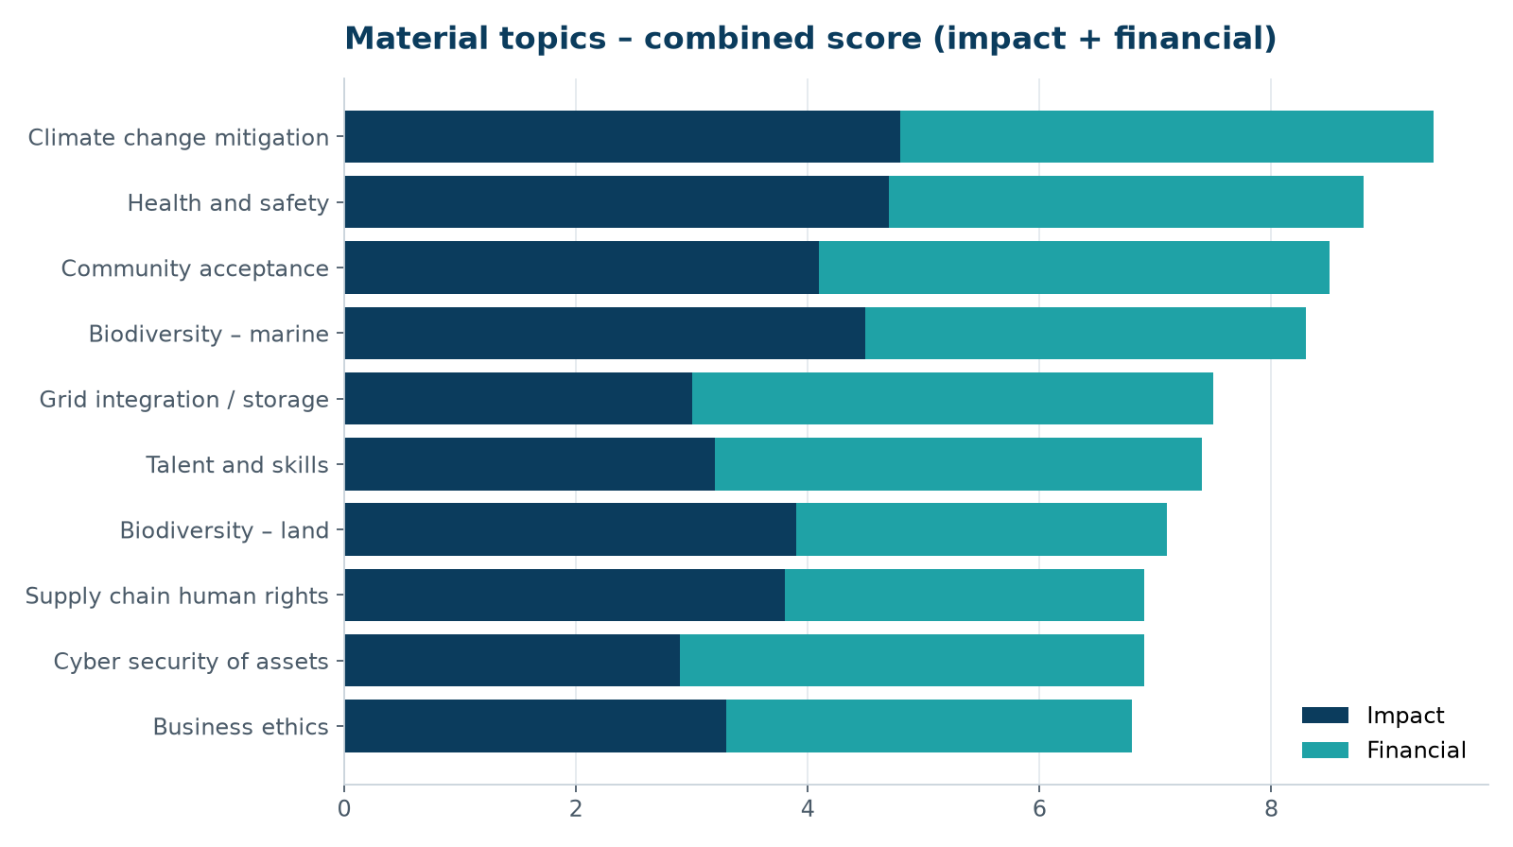
Top ten topics by combined score.
# | Topic | ESG | Impact | Financial | Material
1 | Climate change mitigation | E | 4.8 | 4.6 | Yes
2 | Biodiversity – marine | E | 4.5 | 3.8 | Yes
3 | Biodiversity – land | E | 3.9 | 3.2 | Yes
4 | Health and safety | S | 4.7 | 4.1 | Yes
5 | Community acceptance | S | 4.1 | 4.4 | Yes
6 | Supply chain human rights | S | 3.8 | 3.1 | Yes
7 | Talent and skills | S | 3.2 | 4.2 | Yes
8 | Diversity and inclusion | S | 3.1 | 2.6 | Yes
9 | Circularity (blades, panels) | E | 3.4 | 2.7 | Yes
10 | Grid integration / storage | E | 3.0 | 4.5 | Yes
11 | Business ethics | G | 3.3 | 3.5 | Yes
12 | Cyber security of assets | G | 2.9 | 4.0 | Yes
13 | Water use | E | 1.6 | 1.4 | No
14 | Noise and visual impact | E | 3.5 | 3.0 | Yes
15 | Affordable energy | S | 3.6 | 2.9 | Yes

3. What stakeholders told us
Group | n | Top concern
Employees | 141 | Health and safety offshore
Neighbours (Millbrook, Kestrel Ridge, Harrow Bay) | 88 | Community benefits and visual impact
Suppliers | 37 | Fair payment terms, long-term volumes
Lenders / investors | 19 | Construction risk, climate KPIs
NGOs and authorities | 27 | Marine biodiversity

4. Next steps
- Map each material topic to policies, actions, targets and KPIs (gap analysis due 30 October)
- Use the matrix to structure chapters 2 to 6
- Repeat the survey every two years; update scores annually

